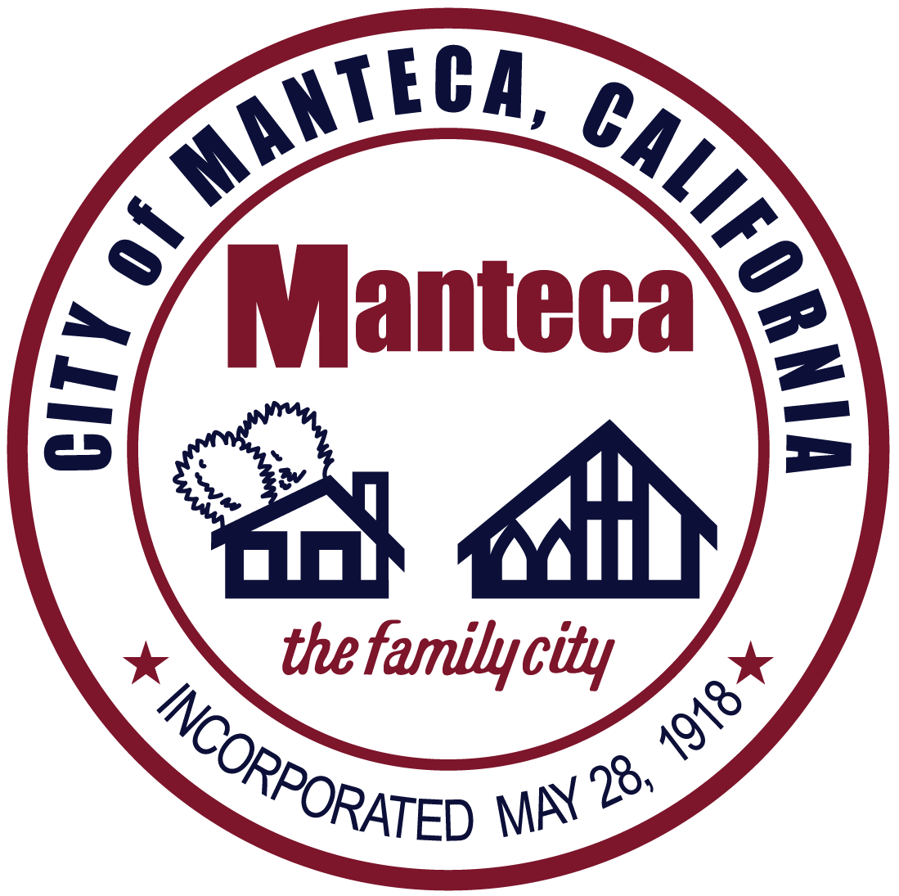
Proclamation

National Law Enforcement Appreciation Day
January 9, 2025

Whereas, across the country on January 9th, citizens take the lead to demonstrate support on National Law Enforcement Appreciation Day; and

Whereas, Law Enforcement Officers of every rank and file have chosen a profession that puts their life on the line every day for their communities. They’ve answered a call to public service that is demanding and often unappreciated. On National Law Enforcement Day, we have an opportunity to thank them for their service and offer a token of respect; and

Whereas, National Law Enforcement Appreciation Day was founded in 2015 to thank officers across the country for all the daily sacrifices they make for their communities. Since then, nationwide many more organizations have joined forces to support National Law Enforcement Appreciation Day (L.E.A.D.) to spread encouragement and respect to these dedicated men and women; and

Whereas, The City of Manteca appreciates the extraordinary efforts and sacrifices made by officers and their family member on a daily basis in order to protect our schools, workplaces, roadways, and homes; and

Now, Therefore, I, Gary Singh, Mayor of the City of Manteca, on behalf of City Council, do recognize January 9, 2025, as National Law Enforcement Appreciation Day can call upon all citizens to show their support for our Manteca Police Officers.

DATE: January 21, 2025

______________________________
Mayor Gary Singh

