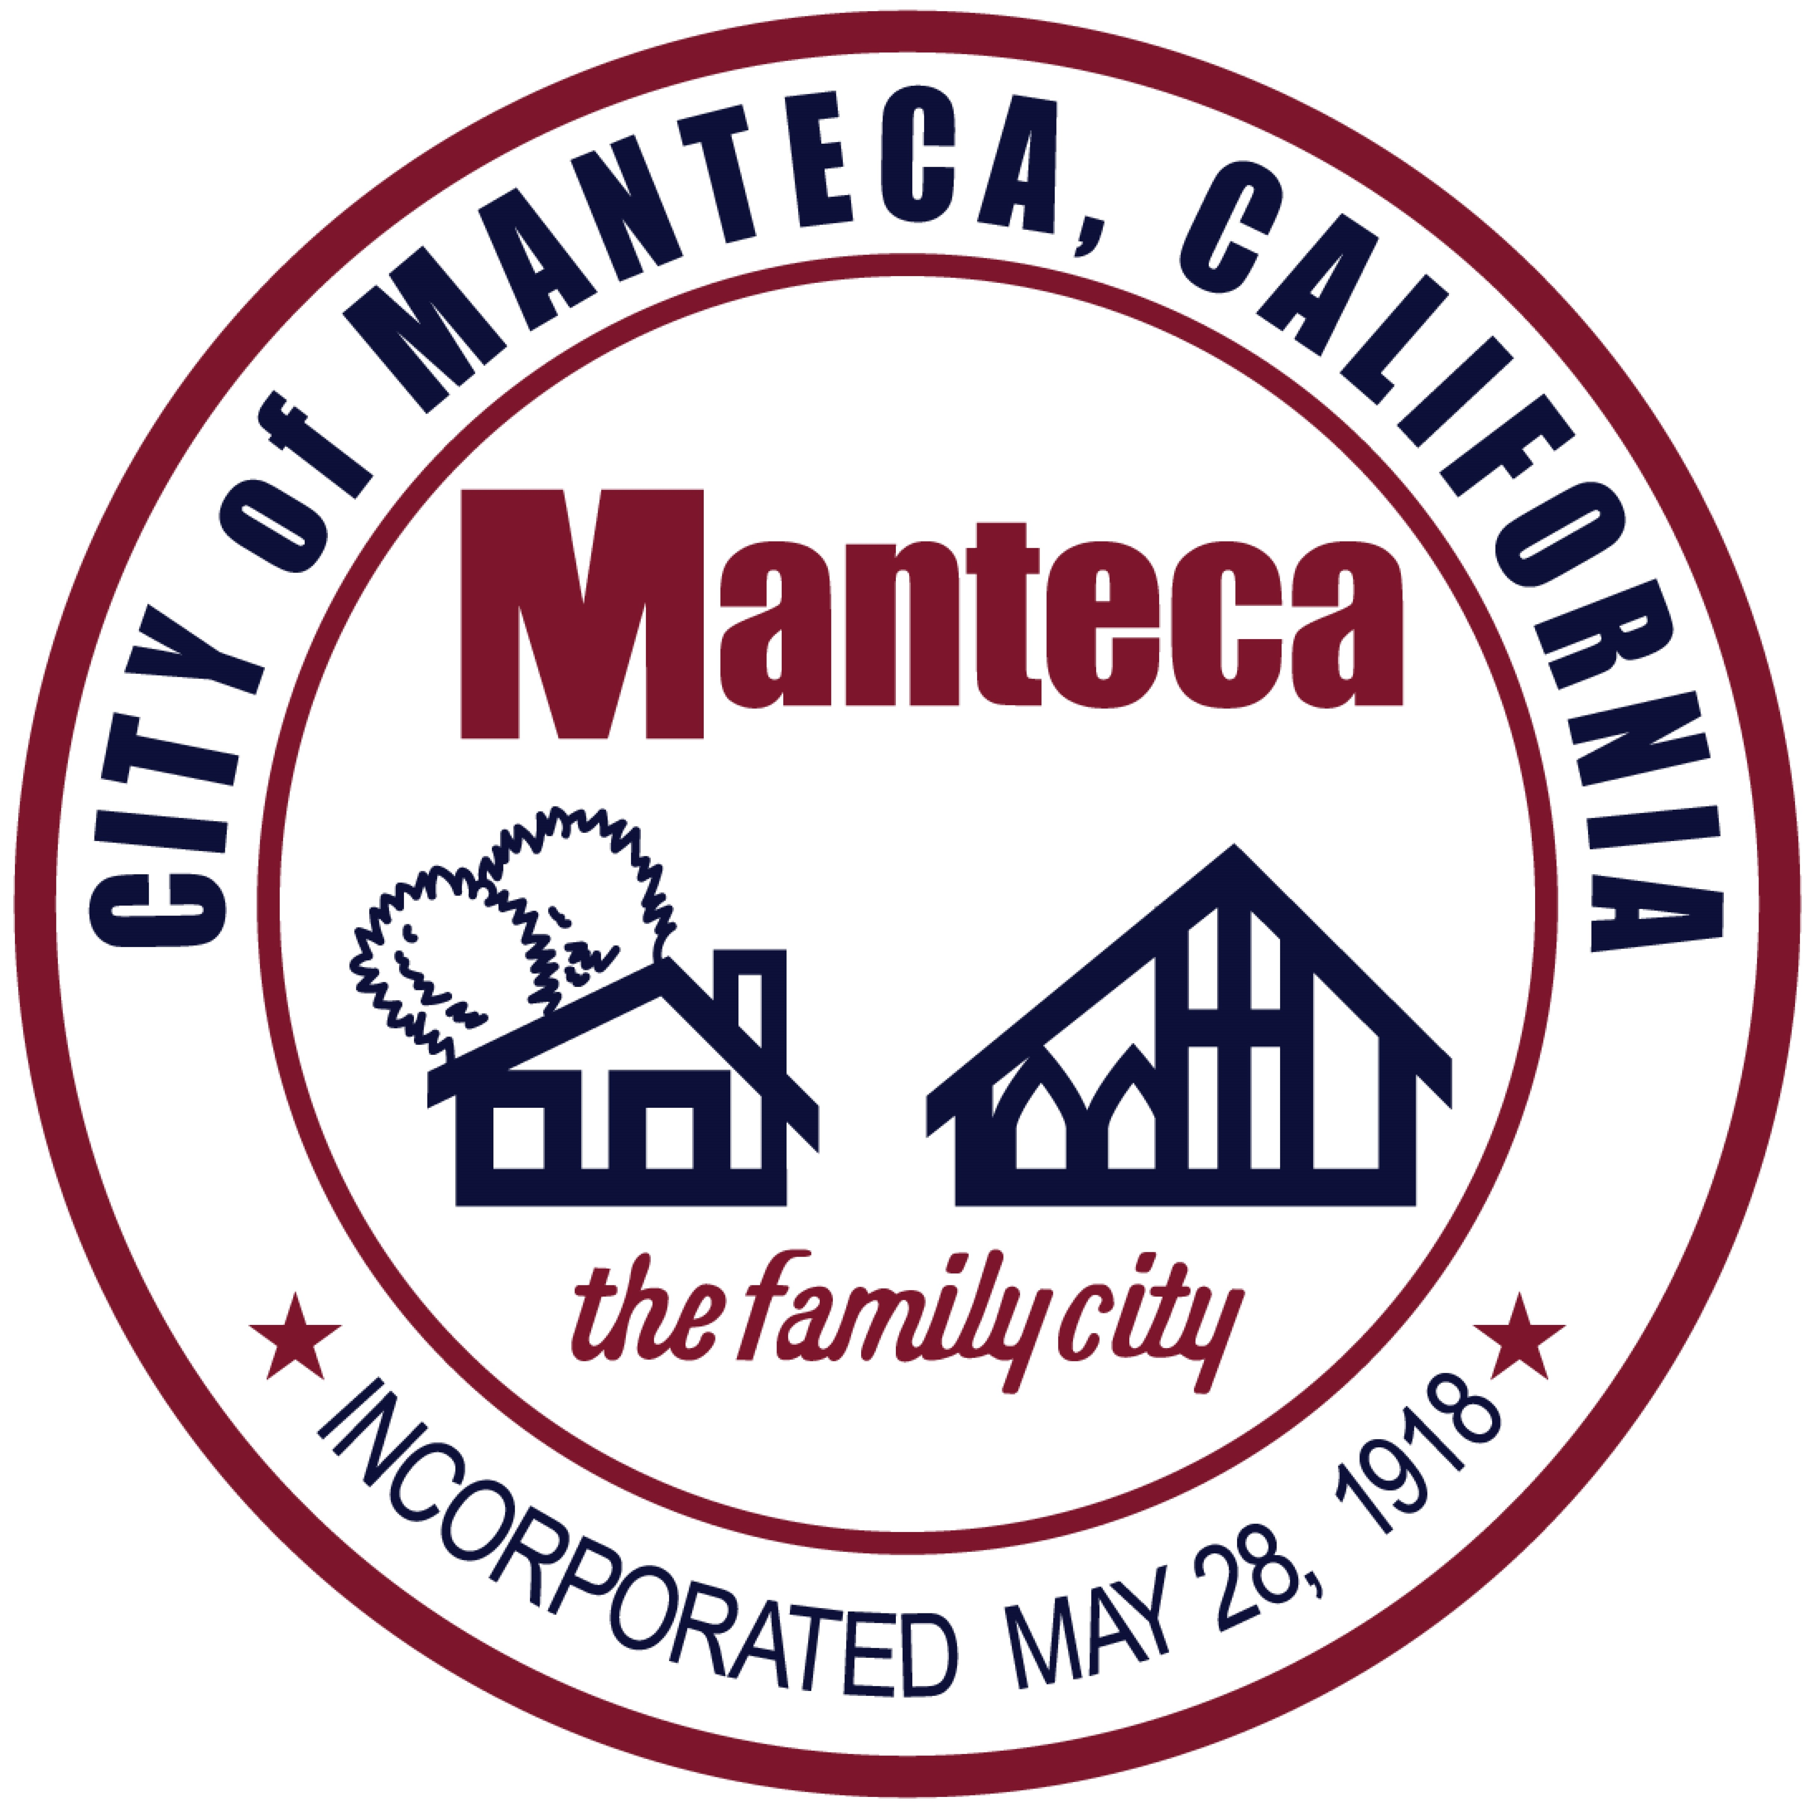

Certificate of Recognition

Presented to

David Marques
Fire Chief

The City of Manteca wishes to thank you for 28 years and 3 months of dedicated service.
May you enjoy many years of good health and happiness.

Date: January 21, 2025

________________________
Mayor Gary Singh

